Apr 2020
Deng, B., Q. Li, X. Liu, Y. Cao, B. Li, Y. Qian, R. Xu, R. Mao, E. Zhou, W. Zhang, J. Huang, and Y. Rao. "Chemoconnectomics: Mapping Chemical Transmission in Drosophila." Neuron 101, no. 5 (Mar 6 2019): 876-93 e4. https://dx.doi.org/10.1016/j.neuron.2019.01.045.
(1). Proposed the concept of the chemoconnectome (CCT): the entire set of all neurotransmitters, neuromodulators, neuropeptides, and their receptors underlying chemotransmission in an animal. (2). Generated knockout lines of Drosophila CCT genes for functional investigations and knockin lines. (3). Detected neuropeptides and receptors in glia; screened genes in regulations.

- attP attB ΦC31: the ΦC31 integrase system
https://systembio.com/wp-content/uploads/FC31_webinar_slides-02-07-2013-1.pdf
ΦC31 integrase is a sequence-specific serine recombinase from a phage, which can integrate phage genome into specific ~34-bp sequence (attB site) in host genome.
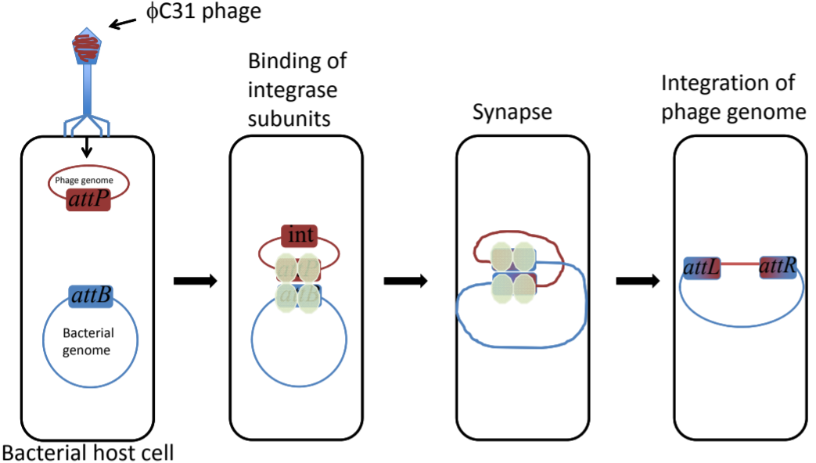
ΦC31 integrase catalyzes unidirectional chromosomal integration at native sites with partial attP identity.
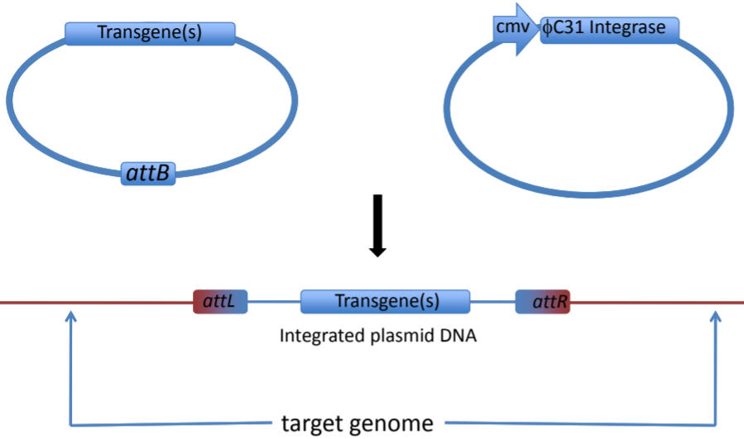
- ends-in and ends-out method (of KO lines)
http://baloun.entu.cas.cz/zurovec/eng/research/hr.html
ends-in and ends-out versions differ in their end products, so that the ends-in results in gene duplication, whereas the ends-in variant results in the direct gene replacement. Both of them work quite efficiently.
Ends-in needs one more enzyme: a recombinase whose action is to loop out a circular copy of the gene of interest
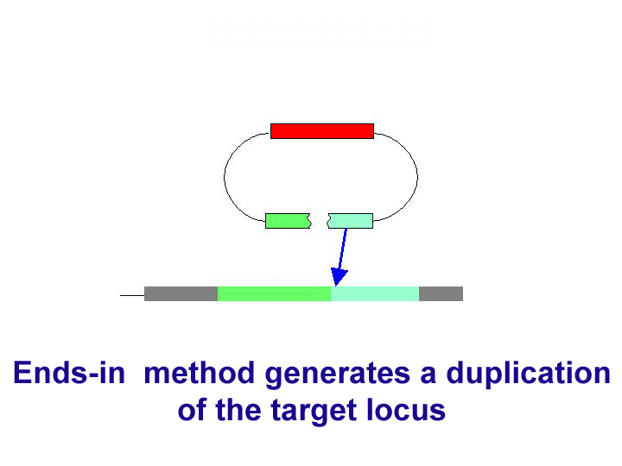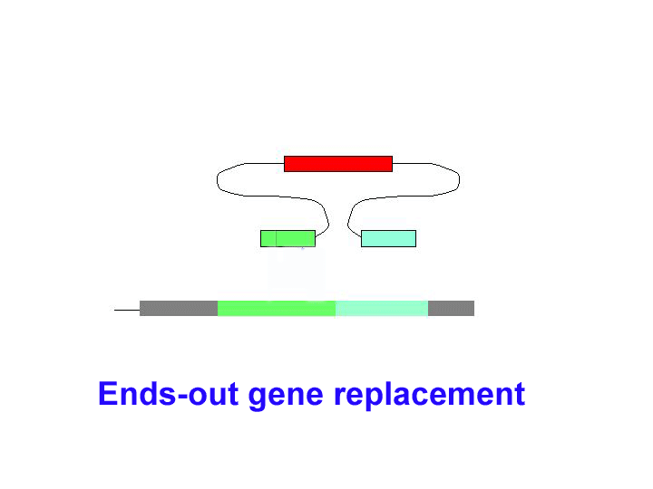
- Gal4/UAS/p65AD KI system
Used to investigate whether two neurotransmitters/neuropeptides (in this figure: X & TH) were expressed together.
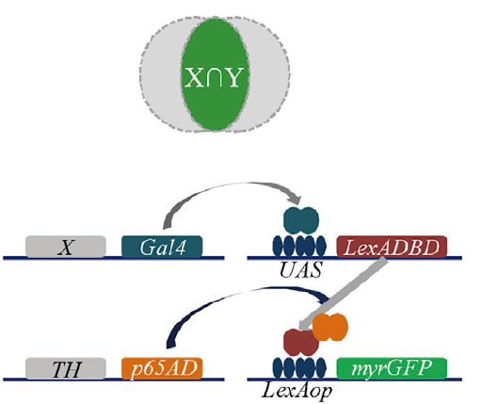
- FLP-FRT system
Analogous to Cre-Lox recombination.
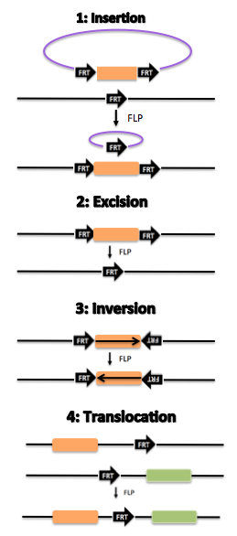
- Gene trapping (and maybe protein trapping???)
A high-throughput approach that is used to introduce insertional mutations across an organism’s genome.
Trapping is performed with gene trap vectors whose principal element is a gene trapping cassette consisting of a promoterless reporter gene and/or selectable genetic marker, flanked by an upstream 3’ splice site and a downstream transcriptional termination sequence (polyA).
When inserted into an intron of an expressed gene, gene trapping works. The processed fusion transcript encodes a truncated and nonfunctional version of the cellular protein and the reporter/selectable marker.
Thus, gene traps simultaneously inactivate and report the expression of the trapped gene at the insertion site, and provide a DNA tag (gene trap sequence tag, GTST) for the rapid identification of the disrupted gene.
(from wikipedia)
//////////////////////////////////////////////////////////////////////////
PAM sequence in CRISPR-Cas9 system
https://www.synthego.com/guide/how-to-use-crispr/pam-sequence
(nice video)
May 2020
- 2A self-cleaving peptides
https://en.wikipedia.org/wiki/2A_self-cleaving_peptides
2A self-cleaving peptides, or 2A peptides, is a class of 19-22 aa-long peptides, which can induce the cleaving of the recombinant protein in a cell. These peptides share a core sequence motif of DxExNPGP. They help break apart polyproteins by causing the ribosome to fail at making a peptide bond.
The members of 2A peptides are named after the virus in which they have been first described. For example, F2A(least efficient) P2A(most efficient) E2A F2A.
In genetic engineering, the 2A peptides are used to cleave a longer peptide into two shorter peptides.
2A peptides, when combined with the IRES elements, can make it possible to generate four separated peptides within a single transcript.
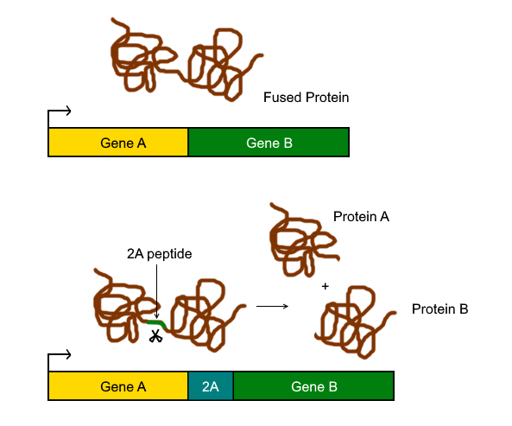
- IRES elements
https://en.wikipedia.org/wiki/Internal_ribosome_entry_site
An internal ribosome entry site, abbreviated IRES, is an RNA element that allows for translation initiation in a cap-independent manner, as part of the greater process of protein synthesis. In eukaryotic translation, initiation typically occurs at the 5' end of mRNA molecules, since 5' cap recognition is required for the assembly of the initiation complex. The location for IRES elements is often in the 5'UTR, but can also occur elsewhere in mRNAs.
In recent years it has become common for molecular biologists to insert IRES sequences into their vectors to allow for expression of two genes from a single vector - for example, a transgene and a fluorescent reporter molecule. The first gene is initiated at the normal 5' cap, and the second gene is initiated at the IRES.
- Subthreshold membrane potential oscillations
https://en.wikipedia.org/wiki/Subthreshold_membrane_potential_oscillations
Subthreshold membrane potential oscillations are membrane oscillations that do not directly trigger an action potential since they do not reach the necessary threshold for firing. However, they may facilitate sensory signal processing. In some types of neurons, the membrane potential can oscillate at specific frequencies. These oscillations can produce firing by joining with depolarizations. Although subthreshold oscillations do not directly result in neuronal firing, they may facilitate synchronous activity of neighboring neurons. It may also facilitate computation, particularly processing of sensory signals.

////////////////////////////////////////////////////////////////////////////////////////

“Tyrosine phosphorylation of the AMPA receptor subunit GluA2 gates homeostatic synaptic plasticity”

GluA2 Y876是3Y之一(Y869 Y873 Y876), 而3Y会block LTD, 对LTP无作用. 最近发现Y876在mGluR-LTD中会dephosphorylation, 但实际上Y876在LTD中的necessity仍然未知. 另外, GluA2 tyrosinephosphorylation参与synaptic scaling, 3Y的phosphorylation与upscaling / downscaling有关, 但是具体其中哪一个位点是相关的及其necessity仍然未知.

本研究: 构建了GluA2 Y876F mice, 发现Hebbian plasticity正常, 但是upscaling有缺陷. 另外发现Y876F阻止了upscaling中GRIP1的增加. 最后发现Y876 phosphorylation增加了GRIP1 binding.
1. 构建了GluA2 Y876F line, 用phosphatase NV和kinase inhibitor PP2分析Y876的磷酸化情况, western blot仍有信号, 发现是GluA3 phospho-Y881产生的信号. (同理发现GluA2 S880和GluA3 S885也是类似的情况)
2. Subcellular fractionation +western blot测定total /PSD protein, 发现总蛋白没有改变,而PSD中GluA2表达下降.
3. Y876F mice中, 用paired-pulselow-frequency stimulation (ppLFS) in the presence of (APV)诱导mGluR-LTD, 发现fEPSPs与对照组相当; 用LFS诱导NMDAR-LTD, 发现也与对照组相当; 用theta-burst stimulation (TBS)诱导NMDAR-LTP,结果与对照组相当. 另外, paired-pulse ratios(PPRs)相当: presynaptic function正常; input/output (I/O) relationships相当: baseling synaptic strength正常.
4. GluA2 phospho-Y876 is required for in vitro upscaling. 用TTX (voltage-gated sodium channel antagonist) 诱导upscaling, 用Bic (GABAR antagonist) 诱导downscaling. Surface biotinylation + western blot测定surface / total proteins. Upscaling / downscaling会影响GluA1 / GluA2的表达量 (downscaling还影响GluA3). 在mutant mice中, downscaling正常, 但upscaling减弱了. 又用surface staining确认了结果.
5. GluA2 phospho-Y876 is necessary for in vivo upscaling. 用binocular enucleation诱导in vivo upscaling, 用subcellular fractionation to obtain PSD fraction, 之后western blot. 结果与in vitro结果相符.
6. Synaptic scaling bidirectionally regulates GluA2 phospho-Y876 but not GluA3 phospho-Y881. 用immunoprecipitation分别确定Y876和Y881的磷酸化水平,发现during scaling, Y876 is bidirectionally regulated, but Y881 is not changed (in vitro / in vivo).
7. GluA2 Phospho-Y876 Is Required for increase in GRIP1 during Upscaling.用subcellular fractionation方法发现TTX & enucleation -induced upscaling中synaptic GRIP1增加; 相反, Y876F mice中没有这种增加.
8. Phosphorylation of GluA2 Y876 increases binding of GRIP1 to GluA2. 用NV treatment增加Y876 phosphorylation level (mutant & WT mice), 之后用coimmunoprecipitation with an anti-GRIP1 antibody + immunoblot for GluA2 and normalized it to the amount of immunoprecipitated GRIP1, 实现对GRIP1-GluA2 binding的定量. WT中NV treatment> control, Y876F中没有这种现象. 又用anti-GluA2 antibody做了一次Co-IP,得到相似结果. 之后又在HEK293 line中做了相似实验, 得到相似结果.
------------------------------------------------------------------------------
1. Generate GluA2 Y987F knock-in mice that are phosphodeficient at Y876 by homologous recombination.
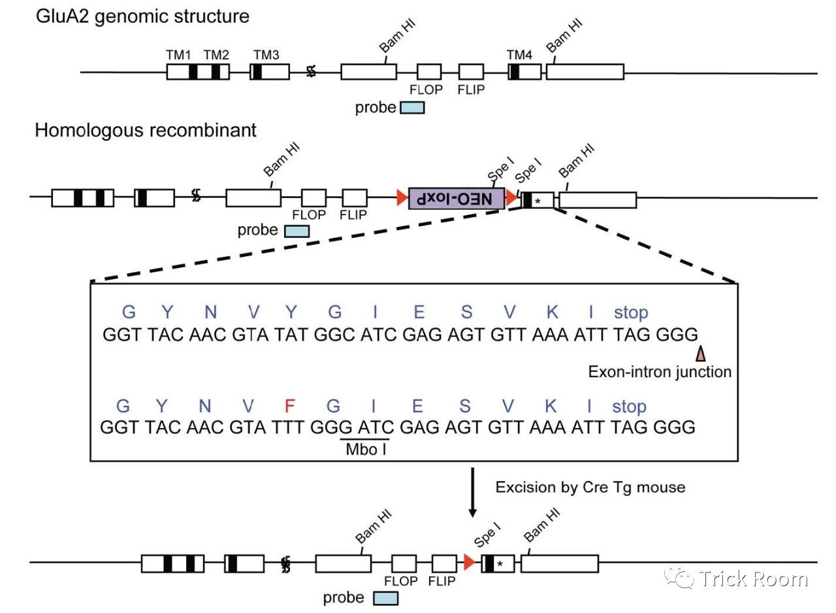
在同源序列中引入了一个Mbo Ⅰ位点, 便于screen mutant allele (酶切之后western blot), 引入一个neoresistance cassette也是为了在western blot中区分条带, 之后用Cre酶切除即可.
2. 实验方法
Induce mGluR-LTD: paired-pulse low-frequency stimulation (ppLFS) in the presence of APV;
Induce NMDAR-LTD: LFS;
Paired-pulse ratio (PPRs)- presynaptic function
Input / output (I / O) relationship– synaptic strength
3. Surface biotinylation
NeutrAvidin bead / agarose
用于extract & isolate cell surface proteins
4. Surface staining
Jun 2020
- myc-tag; myc-GluA2
https://en.wikipedia.org/wiki/Myc-tag
A myc tag is a polypeptide protein tag derived from the c-myc gene product that can be added to a protein using recombinant DNA technology. It can be used for affinity chromatography, then used to separate recombinant, overexpressed protein from wild type protein expressed by the host organism. It can also be used in the isolation of protein complexes with multiple subunits.
A myc tag can be used in many different assays that require recognition by an antibody. If there is no antibody against the studied protein, adding a myc-tag allows one to follow the protein with an antibody against the Myc epitope. Examples are cellulite localization studies by immunofluorescence or detection by Western blotting.
Myc-GluA2: myc epitope tag fusion to GluA2 N terminus.
- IOSI (intrinsic optic signal imaging) / ISOI
https://www.photometrics.com/learn/electrophysiology/intrinsic-signal-optical-imaging
Intrinsic signal optical imaging (ISOI) is a technique used to map dynamics in single cells, brain slices and even entire mammalian brains. It is label-free, minimally invasive and gives the researcher access to the basic physiology of a functioning brain.
ISOI is similar to fMRI in that it relies upon measuring areas of oxygenated vs deoxygenated blood to construct activity, but rather than using an MRI machine is uses light and a scientific camera. ISOI takes advantage of the spectral properties of haemoglobin, which has different absorption properties when oxygenated or deoxygenated.
The basic principle of ISOI is that when brain tissue is directly illuminated, the active areas reflect less light than non-active. The more active a brain area the less light reflected, making highly active areas appear darker. There are three main reasons why neuronal tissues change their optical properties when active: active neurons scatter more light (due to swelling and ion movements), natural fluorophores within the cells react (including haemoglobin) and the changes in blood volume / oxidation.
In a word, a kind of auto-fluorescent imaging.
- Patch clamp
https://en.wikipedia.org/wiki/Patch_clamp#Outside-out_patch
Variations:
(1). Cell-attached patch
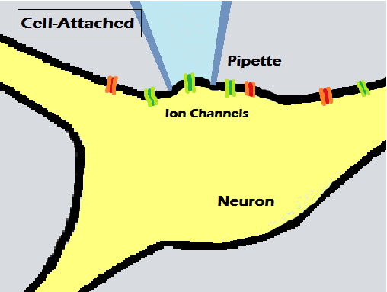
(2). Inside-out patch
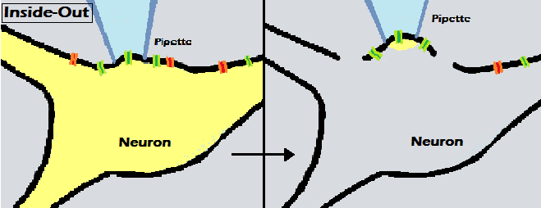
(3). Whole-cell recording or whole-cell patch
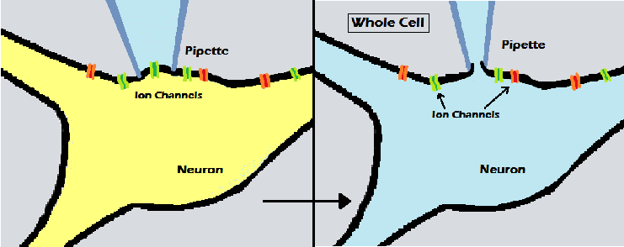
(4). Outside-out patch
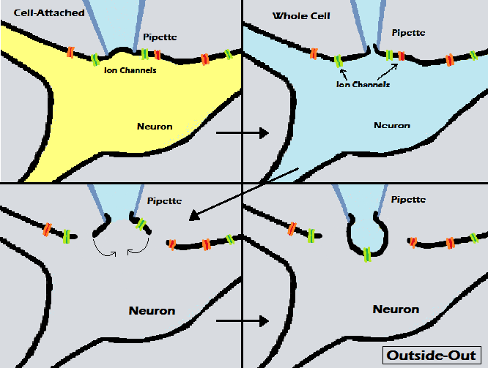
(5). Perforated patch
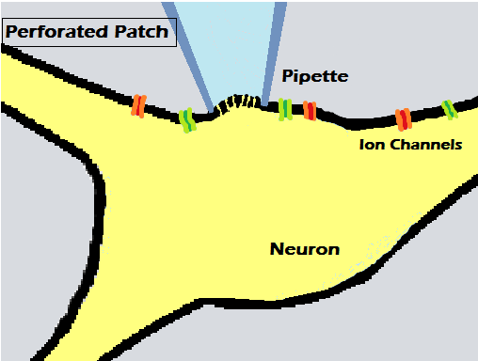
(6). Loose patch
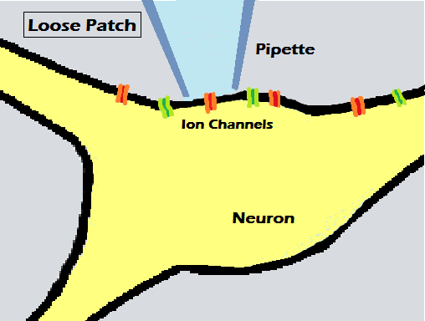
- Paired-pulse ratio (PPR) & paired-pulse facilitation (PPF) / neural facilitation
When a synapse is stimulated in rapid succession, the second post-synaptic response can be larger than the first and termed paired-pulse facilitation. It has been reported that the paired-pulse ratio (PPR), which is the ratio of the amplitude of the second response to that of the first, depends on the probability of vesicular release at the synapse, and PPR has been used as an easy measure of the release probability.
https://en.wikipedia.org/wiki/Neural_facilitation
PPF is a form of short-term synaptic plasticity. The mechanisms underlying neural facilitation are exclusively pre-synaptic; broadly speaking, PPF arises due to increased presynaptic Ca²⁺ concentration leading to greater release of neurotransmitter-containing synaptic vesicles.
Short-term depression (STD, ∈short-term synaptic plasticity) operates in the opposite direction of facilitation, decreasing the amplitude of PSPs (postsynaptic potentials). STD occurs due to a decrease in the readily releasable pool of vesicles as a result of frequent stimulation. The inactivation of presynaptic Ca²⁺ channels after repeated action potentials also contributes to STD. Depression and facilitation interact to create short-term plastic changes within neurons, and this interaction is called the dual-process theory of plasticity.
https://wiki.brown.edu/confluence/display/BN0193S04/paired+pulse+facilitation+index#:~:text=The%20paired%20pulse%20facilitation%20index,probability%20of%20the%20presynaptic%20cell.
PPF is a kind of presynaptic plasticity that reflects the release probability of the presynaptic cell. If the presynaptic cell has high release probability, then the first pulse will deplete the available transmitter, and the second pulse will cause less transmitter to be release, leading to a low PPF or even PPD (depression). If the presynaptic cell has a low release probability, then the first spike will cause a small postsynaptic response, but the build-up of calcium in the presynaptic terminal will lead to an increased release probability on the second spike and as a result, greater transmitter release and a greater postsynaptic response, and a higher PPF.
- Excitatory postsynaptic potential (EPSP) & inhibitory postsynaptic potential (IPSP) (& reversal potential)
https://en.wikipedia.org/wiki/Excitatory_postsynaptic_potential
EPSP is a postsynaptic potential that makes the postsynaptic neuron more likely to fire an action potential. The flow of ions that causes an EPSP is an excitatory postsynaptic current (EPSC). EPSPs, like IPSPs, are graded (i.e. they have an additive effect). EPSPs in living cells are caused chemically.
The release of neurotransmitter vesicles from the presynaptic cell is probabilistic. In fact, even without stimulation of the presynaptic cell, a single vesicle will occasionally be released into the synapse, generating miniature EPSPs (mEPSPs). (quantal nature of synaptic transmission)
Field EPSPs (fEPSPs). The extracellular signal from a single neuron is extremely small and thus next to impossible to record in the human brain. However, in some areas of the brain, such as the hippocampus, neurons are arranged in such a way that they all receive synaptic inputs in the same area. Because these neurons are in the same orientation, the extracellular signal that can easily be recorded with a field electrode. This extracellular signal recorded from a population of neurons is the field potential. In studies of hippocampal LTP, figures are often given showing the field EPSP (fEPSP) in stratum radiatum of CA1 in response to Schaffer collateral stimulation. This is the signal seen by an extracellular electrode placed in the layer of apical dendrites of CA1 pyramidal neurons. The voltage deflection recorded during a field EPSP in negative-going, while an intracellularly recorded EPSP is positive-going (due to the relative flow of ions). In other regions than CA1 of the hippocampus, the fEPSP may be far more complex and harder to interpret as the source and sinks are far less defined.
https://en.wikipedia.org/wiki/Inhibitory_postsynaptic_potential
An inhibitory postsynaptic potential (IPSP) is a kind of synaptic potential that makes a postsynaptic neuron less likely to generate an action potential. This system IPSPs can be temporally summed with subthreshold or suprathreshold EPSPs to reduce the amplitude of the resultant postsynaptic potential.
Depolarization can also occur due to an IPSP if the reverse potential is between the resting threshold and the action potential threshold.
https://en.wikipedia.org/wiki/Reversal_potential
In a biological membrane, the reversal potential (also known as the Nernst potential) of an ion is the membrane potential at which there is no net (overall) flow of that particular ion from one side of the membrane to the other. In the case of post-synaptic neurons, the reversal potential is the membrane potential at which a given neurotransmitter causes no net current flow of ions through that neurotransmitter receptor’s ion channel.
- Probe trials of Morris water maze
http://www.scholarpedia.org/article/Morris_water_maze
During or after training is complete, the experimenter conducts a probe trial in which the escape platform is removed from the pool and the animal allowed to swim for 60 sec. Typically, a well-trained rat will swim to the target quadrant of the pool and repeatedly across the former location of the platform until starting to search elsewhere. This spatial bias, measured in various ways, constitutes evidence for spatial memory. Rats with lesions of the hippocampus and dentate gyrus, subiculum, or combined lesions, do poorly in post-training probe tests.
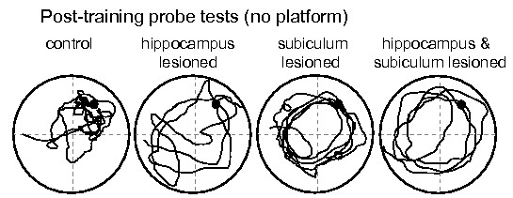
- Reference memory
https://dictionary.apa.org/reference-memory
In animal cognition, the representation of an association between objects, spatial locations, or other stimuli that remains consistent across several trials of an experimental session and is used to guide behavior. Matching to sample and various other tasks involving simultaneous or successive discrimination are commonly used to assess reference memory in nonhuman animals.
<Mickael Joseph. Reference memory, working memory and adaptive forgetting : a comparative study in rats. Neurons and Cognition>
Reference memory (RM) refers to the ability to store information about a specific fixed situation. It is the memory for rules and procedures that re-occur across specific situations. RM involves storing information that remains constant over time, such as the animal’s memory of the geography of its territory.
Several theoretical distinctions can be made between working memory (WM) and RM. One is that WM is used for only one-trial in an experiment and the animal is better off discarding these information once retrieved, whereas RM is trial-independent as the information available for performing the task is constant from trial to trial.
- Cell surface protein biotinylation and analysis
A great way to specifically isolate and quantify proteins in the cell surface membrane is to take advantage of the biotinylation technique. It consists of labeling cell surface proteins with a biotin reagent before lysing the cells, and isolating these tagged proteins by NeutrAvidin pull-down. Then, the samples are subjected to SDS-PAGE separation, transferred to PVDF membranes and probed with specific antibodies. Quantification of cell surface expression is accomplished by densitometric measurement of the bands corresponding to the protein of interest and subsequent normalization by a membrane protein (as control).
- Staining marker: MAP2 (for dendritic spines), synaptophysin (presynaptic marker)
- Afterhyperpolarization (AHP) & slow afterhyperpolarization (sAHP)
https://en.wikipedia.org/wiki/Afterhyperpolarization
AHP is the hyperpolarizing phase of a neuron’s action potential where the cell’s membrane potential falls below the normal resting potential. This is also commonly referred to as an action potential’s undershoot phase. AHPs have been segregated into “fast”, “medium”, and “slow” components that appear to have distinct ionic mechanisms and durations. While fast and medium AHPs can be generated by single action potentials, slow AHPs generally develop only during trains of multiple action potentials.
Mechanism: (1) during single action potentials, more voltage-gated K⁺ channels are open than in the resting state and do not close immediately when the membrane returns to its normal resting voltage. (2) Ca²⁺-activated K⁺ channels open during action potential. The unusually high permeability of K⁺ driving the membrane voltage V_{M} even closer to the K⁺ equilibrium voltage E_{K}. The hyperpolarization persists until the membrane K⁺ permeability returns to its usual value.
The mechanisms underlying medium and slow AHPs are not yet understood.
sAHP refers to prolonged periods of hyperpolarization in a neuron or cardiomyocyte following an action potential or other depolarizing event. In neurons, trains of action potentials may be required to induce sAHPs; this is unlike fast AHPs that require no more than a single action potential. Depending on neuron type and stimulus used for induction, slow afterhyperpolarizations can last for one second to several tens of seconds, during which time the sAHP effectively inhibits neural activity.
- Microdialysis
https://www.google.com/search?q=microdialysis&oq=microdialysis&aqs=chrome..69i57j0l7.4912j0j7&sourceid=chrome&ie=UTF-8
Microdialysis is a minimally-invasive sampling technique that is used for continuous measurement of free, unbound analyte concentrations in the extracellular fluid of virtually any tissue. Analyte may include endogenous molecules (small-molecular-weight) (e.g. neurotransmitter, hormones, glucose, etc.) to assess their biochemical functions in the body, or exogenous compounds (e.g. pharmaceuticals) to determine their distribution within the body. The microdialysis technique requires the insertion of a small microdialysis catheter (also referred to as microdialysis probe) into the tissue of interest. The microdialysis probe is designed to mimic a blood capillary and consists of a shaft with a semipermeable hollow fiber membrane at its tip, which is connected to inlet and outlet tubing. The probe is continuously perfused with an aqueous solution (perfusate) that closely resembles the (ionic) composition of the surrounding tissue fluid at a low flow rate. Once inserted into the tissue or (body) fluid of interest, small solutes can cross the semipermeable membrane by passive diffusion. The direction of the analyte flow is determined by the respective concentration gradient and allows the usage of microdialysis probes as sampling as well as delivery tools. The solution leaving the probe (dialysate) is collected at certain time intervals for analysis.
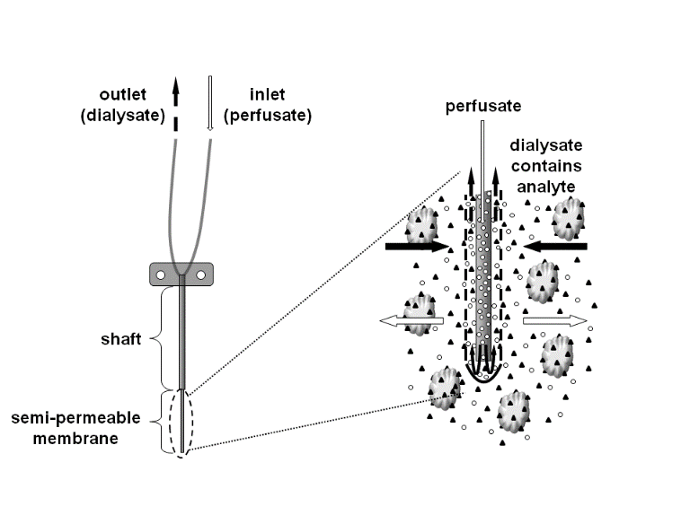
- Fast-scan cyclic voltammetry (FSCV)
https://en.wikipedia.org/wiki/Voltammetry#Theory
Voltammetry: is a category of electroanalytical methods used in analytical chemistry and various industrial processes. In voltammetry, information about an analyte is obtained by measuring the current as the potential is varied. The analytical data for a voltammetric experiment comes in the form of a voltammagram which plots the current produced of the working electrode.
https://en.wikipedia.org/wiki/Cyclic_voltammetry
Cyclic voltammetry (CV): CV is a type of potentiodynamic electrochemical measurement. In a cyclic voltammetry experiment, the working electrode potential is ramped linearly versus time. After the set potential is reached in a CV experiment, the working electrode’s potential is ramped in the opposite direction to return to the initial potential. These cycles of ramps in potential may be repeated as many times as needed. CV is generally used to study the electrochemical properties of an analyte in solution or of a molecule that is adsorbed onto the electrode.
https://en.wikipedia.org/wiki/Fast-scan_cyclic_voltammetry
Fast-scan cyclic voltammetry (FSCV): FSCV is cyclic voltammetry with a very high scan rate. Application of high scan rate allows rapid acquisition of a voltammogram within several milliseconds and ensure high temporal resolution of this electroanalytical technique. FSCV in combination with carbon-fiber microelectrodes became a very popular method for detection of neurotransmitters, hormones and metabolites in biological systems. FSCV enables detection of 5-HT, HA, norepinephrine, adenosine, oxygen, pH changes in vivo in rats and mice as well as measurement of dopamine and serotonin concentration in fruit flies.
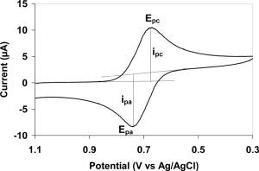
- Gene gun / biolistic particle delivery system / biolistics / biolistic transfection
https://en.wikipedia.org/wiki/Gene_gun
In genetic engineering, a gene gun or biolistic particle delivery system is a device used to deliver exogenous DNA (transgenes), RNA, or protein to cells. By coating particles of a heavy metal with a gene of interest and firing these micro-projectiles into cells using mechanical force, an integration of desired genetic information can be induced into cells. The technique involved with such micro-projectile delivery of DNA is often referred to as biolistics.
This device is able to transform almost any type of cell and is not limited to the transformation of the nucleus; it can also transform organelles, including plastids and mitochondria.
(used in: “A Highly Sensitive A-Kinase Activity Reporter for Imaging Neuromodulatory Events in Awake Mice”)
- Iontophoresis / microelectrophoresis:
Used to apply a short pulse of NE to CA1 neuronal dendrites (“A Highly Sensitive A-Kinase Activity Reporter for Imaging Neuromodulatory Events in Awake Mice”)
- Tissue clearing technique / PGASOS tissue clearing method / transparent embedding solvent system (TeSOS)
Classes: (1) solvent-based / hydrophobic clearing methods, (2) hydrogel-based clearing method, (3) aqueous / hydrophilic clearing method.
Hydrophobic tissue-clearing: 3DISCO (3D imaging of solvent-cleared organs) (and other DISCO-based methods)
Hydrophilic tissue-clearing: FocusClear, Scale, ScaleS, SeeDB (See Deep Brain), SeeDB2, CUBIC reagents, CUBIC-X
Hydrogel-based tissue-clearing: CLARITY (cleared lipid-extracted acryl-hybridized rigid immunostaining / in situ hybridization – compatible tissue hydrogel), PACT (passive CLARITY technique, a variant of CLARITY), MAP (magnified analysis of proteome), SHIELD (stabilization to harsh conditions via intramolecular epoxide linkages to prevent degradation), PARS (perfusion-assisted agent release in situ)
Pros and cons:
 | Pros | Cons
Solvent | High RI  (refractive index)  High transparency | GFP fluorescence damage  Autofluorescence  Tissue shrinkage
Aqueous / hydrogel | Better GFP reservation | Tissue expansion  Not applicable for hard tissue
General processes of tissue clearing:
(1). Perfusion and fixation, (2). Decalcification (for hard tissues), (3). Decolorization, (4). Delipidation / degreasing, (5). Dehydration (for solvent-based clearing methods), (6). RI-matching.
(1). Perfusion and fixation: 4% paraformaldehyde (PFA) is the most commonly used fixative. Although PFA treatment significantly reduced endogenous GFP intensity, fixation helps GFP protein to resist following harsh chemical treatments. Without the crosslinking effect caused by PFA, tissue proteins degrade easily. Over-longed PFA treatment did not provide extra protection benefit, but denatured GFP protein permanently.
(2). Decalcification (only for hard tissues) (EDTA is commonly used)
(3). Decolorization: hydrogen peroxide (H₂O₂) was first reagent been used for decolorization in the iDISCO method, but it also rapidly quenches endogenous fluorescence including GFP and tdTomato etc. Quadrol and N-butyldiethanolamine (丁基二乙醇胺), were developed by the CUBIC method. They were able to decolorize heme efficiently without compromising endogenous GFP signals. Later, Quadrol decolorization turned out to be highly effective and was also adapted by other clearing methods including Bone CLARITY, PEGASOS and vDISCO.
(4). Delipidation / degreasing: in addition to regular detergent (SDS, Triton X-100, thioglycerol (硫代甘油) or saponin (皂苷)) or dichloromethane (二氯甲烷), alcohol or ethers (醚类) like THF (四氢呋喃) or tert-butanol (叔丁醇), which are miscible with both water and organic solvents, can also help to resole lipids and accelerate delipidation.
(5). Dehydration (for solvent-based clearing methods): commonly used dehydration mediums include 100% ethanol, THF, tert-butanol and tB-PEG (tert-butanol plus polyethylene glycol (聚乙二醇)). Complete removal of water from the tissue causes tissue shrinkage and protein denature, which is likely a major cause of GFP fluorescence loss after clearing.
(6). RI-matching with clearing mediums: final step for all clearing treatments. Tissue were filled with homogenous clearing solution to achieve consistent internal RI and transparency could be achieved. Generally, higher RI yields better transparency. Most solvent-based clearing medium possess higher RI (>1.54) than aqueous or hydrogel clearing mediums (RI 1.40~1.51). However, the absence of water within the solvent clearing medium made them less amenable on preserving endogenous GFP activities.
PEGASOS tissue clearing method: (1). Solvent based clearing method with high R.I. (1.54); (2). Superior transparency for both hard and soft tissue organs; (3). PEG component within the clearing medium provides excellent GFP protection for long term.
Processes:
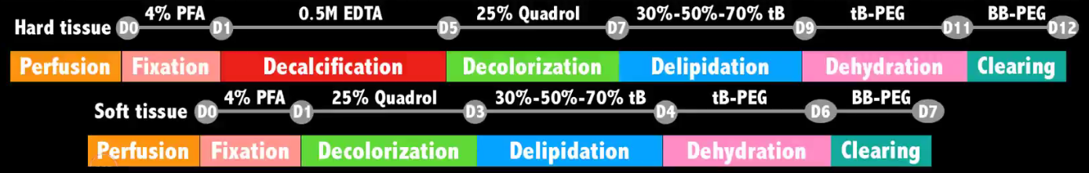
Cleared samples can be preserved in BB-PEG solution for months at R.T. without significant signal reduction.
Advantages: high transparency, GFP preservation, both hard and soft tissue organs. Compatible with Dextran sulfate, GS-IB4, Fluorogold; not compatible with Dil, DiO. Tested compatible fluorophores: tdTomato, EGFP, EYFP, ZsGreen and AlexaFluoro conjugation; might not be compatible with DsRed reporter. Tested dyes: GS-IB4, FluoroGold, Dextran Sulfate and EdU.
TESoS: combination of tissue clearing and block surface imaging (cut off a layer of tissue every time after imaging block surface)
Imaging speed and cost: confocal or two-photon is too slow, light sheet microscope is the future.
Tips: (1). Aqueous / hydrogel - based methods are not fit for light sheet imaging, because evaporation of water changes local RI which causes asymmetry of RI. Sealing film / silicone oil can solve this problem partially. (2). Fluorescence will become weaker after tissue clearing, so strong second antibody reporter should be selected. (3). Auto-fluorescence can be eliminated by imaging through two channels at the same time. (because auto-fluorescence images in many different channels). (4). Degrees of tissue shrinkage is tissue-type-dependent, so interface between different tissues may be transformed or even stripped.
- Light-sheet microscopy / light sheet fluorescence microscopy (LSFM)
<Tissue clearing and its applications in neuroscience>
The central idea in light-sheet microscopy is to illuminate the specimen with a thin sheet of laser light from the side and acquire an image of the illuminated plane with a camera-based detection system. In the most common implementations of light-sheet microscopy, the wide-field detection arm is oriented at a right angle to the light-sheet illumination axis and separate objectives are used for illumination and detection. Compared with conventional microscopy, this approach offers two primary advantages for the imaging of large tissue volumes. First, the imaging speed is limited only by the acquisition rate of the camera and thus exceptionally high data rates of up to several hundred million voxels per second can be achieved with state-of-the-art sCMOS detectors. Second, photobleaching and phototoxic effects are kept to a minimum, since only the plane in the focus of the detection system is illuminated with laser light. The amount of energy any part of the sample is exposed to is thus constant and independent of the total size of the sample or imaging volume. By contrast, conventional or confocal microscopes, which use the same objective for illumination and detection, illuminate also out-of-focus regions in the imaging process (above and below the focal plane). In these latter methods, local light exposure thus increases linearly with the size of the imaging volume and can even result in complete bleaching of parts of the specimen before volume acquisition is complete.
https://en.wikipedia.org/wiki/Light_sheet_fluorescence_microscopy
LSFM is a fluorescence microscopy technique with an intermediate-to-high optical resolution, but good optical sectioning capabilities and high speed. In contrast to epifluorescence microscopy only a thin slice (usually a few hundred nanometers to a few micrometers) of the sample is illuminated perpendicularly to the direction of observation. For illumination, a laser light-sheet is used, i.e. a laser beam which is focused only in one direction (e.g. using a cylindrical lens). A second method uses a circular beam scanned in one direction to create the lightsheet. As only the actually observed section is illuminated, this method reduces the photodamage and stress induced on a living sample. Also the good optical sectioning capability reduces the background signal and thus creates images with higher contrast, comparable to confocal microscopy.
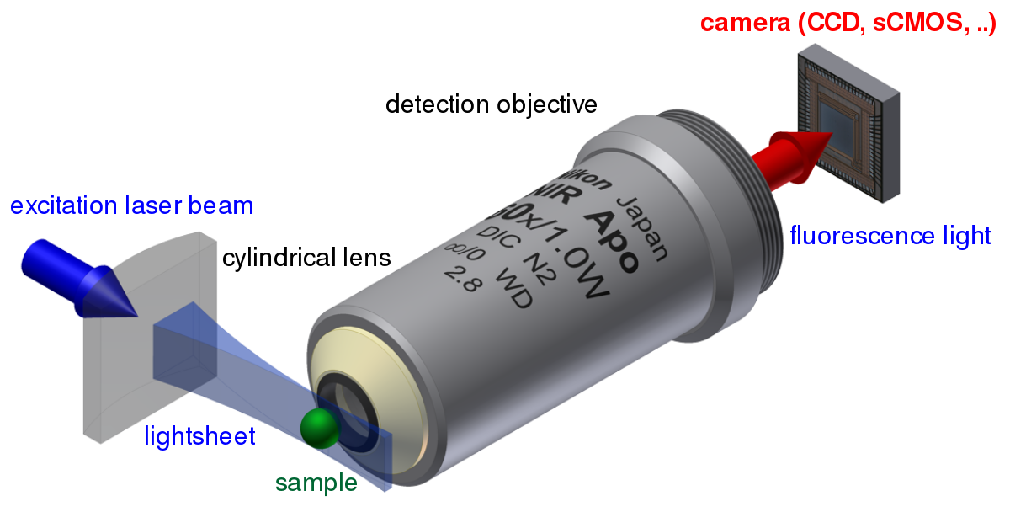
Because LSFM scans samples by using a plane of light instead of a point (as in confocal microscopy), it can acquire images at speeds 100 to 1000 times faster than those offered by point-scanning methods.
This method is used in cell biology and for microscopy of intact often chemically cleared, organs, embryos, and organisms.
- Dimerization-dependent fluorescent proteins (ddFPs)
<Dimerization-Dependent Green and Yellow Fluorescent Proteins>
ddFPs are a recently introduced class of genetically encoded reporters that can be used for the detection of protein interactions in live cells. ddFP technology involves the reversible binding of two dark FP monomers to form a fluorescent heterodimeric complex. The fluorogenic response associated with the FP-FP interaction is an indicator of an increase in the proximity or effective concentration of monomers.
Jul 2020
- Tamoxifen-inducible Cre recombination / temporally control of Cre recombination
https://en.wikipedia.org/wiki/Cre-Lox_recombination
Inducible Cre activation is achieved using CreER (estrogen receptor) variant, which is only activated after delivery of tamoxifen. This is done through the fusion of a mutated ligand binding domain of the estrogen receptor to the Cre recombinase, resulting in Cre becoming specifically activated by tamoxifen. In the absence of tamoxifen, CreER will result in the shuttling of the mutated recombinase into the cytoplasm. The protein will stay in this location in its inactivate state until tamoxifen is given. Once tamoxifen is introduced, it is metabolized into 4-hydroxytamoxifen (4-OHT), which then binds to the ER and results in the translocation of the CreER into the nucleus, where it is then able to cleave the lox sites. Importantly, sometimes fluorescent reporters can be activated in the absence of tamoxifen, due to leakage of a few Cre recombinase molecules into the nucleus which, in combination with very sensitive reporters, result in unintended cell lablling.
- Dominant negative alleles
https://en.wikipedia.org/wiki/Mutation
Dominant negative mutations (also called antimorphic mutations) have an altered gene product that acts antagonistically to the wile-type allele. These mutations usually result in altered molecular function (often inactive) and are characterized by a dominant or semi-dominant phenotype.
- Codon optimization
<A critical analysis of codon optimization in human therapeutics>
Codon optimization refers to experimental approaches designed to improve the codon composition of a recombinant gene based on various criteria without altering the amino acid sequence.
Most codon-optimization approaches avoid the use of rare codons. However, different approaches vary in the extent of other features considered.
- Tetracycline (Tet) inducible expression
https://www.addgene.org/collections/tetracycline/
Tetracycline (Tet),
doxycycline (Dox),
tetracycline-controlled transactivator (tTA), containing tetracycline repressor (tetR),
Tet response element (TRE), containing tetracycline operator (tetO).
Tet-off system: (activate in the absence of Dox)
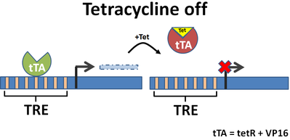
Tet-on system: (activate in the presence of Dox)
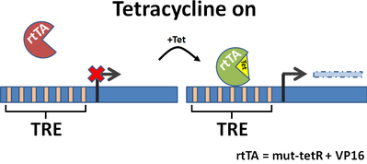
Aug 2020
- 常用特异性启动子
启动子名称 | 特异性细胞表达 | 启动子名称 | 特异性细胞表达
CAG/CBG/CMV/EF1a | 常用广谱启动子 | GFAP | 星形胶质细胞(长启动子)
Nestin | 神经干细胞, 胶质前体 | shortGFAP | 星形胶质细胞(短启动子)
Mash1 | 神经干细胞 | Iba1 | 小胶质细胞
hSyn | 成熟神经元 | CX3CR1 | 小胶质细胞
CaMKⅡα | 投射神经元 | MBP | 少突胶质细胞
GAD67 | GABA能中间神经元 | NG2/NGL2 | 少突胶质细胞前体细胞
mDLx | GABA能中间神经元 | TH | 儿茶酚胺能神经元(DA NE E)
fPV | PV+中间神经元 | PRSx8 | 去甲肾上腺素能神经元
fNYP | NPY+中间神经元 | ChAT | 胆碱能神经元
fSST | SST+中间神经元 | D1/D2 | 多巴胺D1/D2受体神经元
DAT | 多巴胺能神经元 | HCRT | 下丘脑食欲素神经元
L7pcp2 | 小脑浦肯野细胞 | FEV | 五羟色胺能神经元

Sep 2020
Cytomegalovirus promoter (CMV promoter)
The CMV promoter is commonly included in vectors used in genetic engineering work conducted in mammalian cells, as it is a strong promoter and drives constitutive expression of gene under its control. (wikipedia)
CMV promoter, primarily used for general expression, strong mammalian expression promoter from the human cytomegalovirus, constitutive expression, may contain an enhancer region, can be silenced in some cell types (addgene)
U6 Promoter
U6 is a type III RNA polymerase III promoter commonly used for driving small hairpin RNA (shRNA) expression in vector-based RNAi. (article 1)
The endogenous U6 promoter normally controls expression of the U6 RNA, a small nuclear RNA (snRNA) involved in splicing, and has been well-characterized. This particular promoter was chosen to control vector-based expression of shRNA molecules in mammalian cells for the following reasons: the promoter is recognized by RNA polymerase III and controls high-level, constitutive expression of shRNA; the promoter is active in most mammalian cell types. The promoter is a type III Pol III promoter in that all elements required to control expression of the shRNA are located upstream of the transcription start site. (website)
FLAG-tag
FLAG-tag, or FLAG octapeptide, or FLAG epitope, is a polypeptide protein tag that can be added to a protein using recombinant DNA technology, having the sequence motif DYKDDDDK. It is one of the most specific tags and it is an artificial antigen to which specific, high affinity monoclonal antibodies have been developed and hence can be used for protein purification by affinity chromatography and also can be used for locating proteins within living cells.
A FLAG-tag can be used in many different assays that require recognition by an antibody. If there is no antibody against a given protein, adding a FLAG-tag to a protein allows the protein to be studied with an antibody against the FLAG sequence. E.g. immunofluorescence, immunoprecipitation, detection by SDS PAGE protein electrophoresis and Western blotting.
Additionally, FLAG-tag may be used in tandem, commonly the 3xFLAG peptide: DYKDHD-G-DYKDHD-I-DYKDDDDK. It can be fused to the C-terminus or the N-terminus of a protein, or inserted within a protein. The FLAG-tag can be used in conjunction with other affinity tags, for example a polyhistidine tag (His-tag), HA-tag or myc-tag. (wikipedia)
Cholera toxin subunit B (CT-B)
Cholera toxin B subunit attaches to cells by binding to ganglioside GM1, making it a powerful tool for retrograde labeling of neurons. (ThermoFisher)
The major virulence factor (of Vibrio cholerae) is cholera toxin (CT), which consists of two subunits: the A subunit (CTA) and the B subunit (CTB). CTB is a 55kD homopentameric, non-toxic protein binding to the GM1 ganglioside on mammalian cells with high affinity. (article 1)
Alexa Fluor
The Alexa Fluor family of fluorescent dyes is a series of dyes invented by Molecular Probes, now a part of Thermo Fisher Scientific. Alexa Fluor dyes are frequently used as cell and tissue labels in fluorescence microscopy and cell biology. Alexa Fluor dyes can be conjugated directly to primary antibodies or to secondary antibodies to amplify signal and sensitivity or other biomolecules.
The excitation and emission spectra of the Alexa Fluor series cover the visible spectrum and extend into the infrared. The individual members of the family are numbered according roughly to their excitation maxima in nanometers. (wikipedia)
T-maze
In behavioral science, a T-maze (or the variant Y-maze) is a simple maze used in animal cognition experiments. It is shaped like the letter T (or Y), providing the subject, typically a rodent, with a straightforward choice. T-mazes are used to study how the rodent function with memory and spatial learning through applying various stimuli. These concepts of T-mazes are used to assess rodent behavior. The different tasks, such as left-right discrimination and forced alternation, are mainly used with rodents to test reference and working memory.
Other mazes: multi T-maze; Y-maze; radial arm maze.
Purpose: The concepts of T-mazes are used to assess rodent behavior. The different tasks such as left-right discrimination and forced alternation are mainly used with rodents to test reference and working memory. Maze research is used to show how the rodent’s behavior evolves with alternate strategies to do different tasks. (wikipedia)
Thigmotaxis / Thigmotactic behavior (in water maze)
The Morris water maze test (MWM) is a useful tool to evaluate rodents’ spatial learning and memory, but the outcome is susceptible to various experimental conditions. Thigmotaxis is a commonly observed behavioral pattern which is thought to be related to anxiety of fear. This behavior is associated with prolonged escape latency. Thigmotaxis in the early training stage is a predictive factor for impaired performance in MWM.
Thigmotaxis refers to an animal’s propensity to move along the edge of its environment. This behavior is used as a marker of stress for rodents in open-field situations including MWM tasks. (article 1)
SNI (Spared Nerve Injury) Model
The SNI model is a model of neuropathic pain.
The SNI model in rodents is a partial denervation model, in which the common peroneal and tibial nerves are injured, producing consistent and reproducible tactile hypersensitivity in the skin territory of the spared, intact sural nerve. SNI-operated mice require less force applied to the affected limb to elicit a withdrawal behavior as compared to sham mice. This effect is observed as early as 2 days after surgery and lasts for at least 1 month. (article)
Von Frey Hair
A von Frey hair is a type of aesthesiometer. Von Frey filaments rely on the principle that an elastic column, in compression, will buckle elastically at a specific force, dependent on the length, diameter and modulus of the material. Once buckled, the force imparted by the column is fairly constant, irrespective of the degree of buckling. The filaments may therefore be used to provide a range of forces to the skin of a test subject, in order to find the force at which the subject reacts because the sensation is painful. This type of test is called a mechanical nociceptive threshold test.
The buckling force is inversely proportional to the length of the column and proportional to the cube of the diameter, so that increasing the diameter of a filament by a small amount increases the buckling force considerably. Sets of filaments are normally made of nylon hairs, all the same length, but of various diameters so as to provide a range of forces.
The determination of a mechanical threshold using von Frey filaments requires a number of discrete tests using filaments with different buckling forces. There are two commonly used algorithms, the up-down method and the percent response method. (wikipedia)
Oct 2020
Extinction Learning
Extinction learning refers to the gradual decrease in response to a conditioned stimulus that occurs when the stimulus is presented without reinforcement. Extinction learning serves as the foundation of exposure therapy, which is commonly used to treat pathological fear. (article)
Light Sheet Microscopy
光片显微镜可以在较低光毒性和高速情况下对活样品进行三维成像.
现有的3D显微成像方法:
- Laser scanning confocal: 照明光和成像光走同一光路, 照明系统没有光学切片, 只通过成像系统选择焦点成像, 成像效率极低(普通宽场显微镜的1%左右), 激发效率相比双光子高, 光漂白效应和光毒性极高
- Spinning disk microscopy: 转盘显微镜, 原理与普通confocal相同, 成像相比confocal更快
- Multiphoton microscopy: 激发效率低, 成像效率高
- Light sheet microscopy: 照明范围=成像范围, 激发效率高
Light sheet目前无法替代confocal的理由: 搭建难度高, 光源需要额外的空间, 所以只能选择中等倍率水镜物镜, 另外还需要匹配折射率且耐腐蚀的专用镜头
大型透明化样品中不选择confocal成像的原因: (1). 成像过慢, 可能需要数天, 过程中易受到其他因素干扰; (2). 光漂白效应太强
另外, 大型透明化样品成像可能得到很大的数据量, 数据处理过程对算力要求高
 | Confocal | Light sheet
激发效率 | 高 | 高
激发光利用率 | 低(<μm point) | 高(~mm)
成像效率 | 极低 | 高
光漂白 | 极高 | 低
成像速度 | 低 | 高
照明 | 激光点扫描 | 面照明或线扫描
成像 | 共焦针孔, PMT/GaAsP点成像 | 宽场, sCMOS面成像
成像速度 | 1f/s ~ nf/s @512×512  4~10f/s @2048×2048 | 10~100f/s @2048×2048
检测器效率 | 15-40% | >80%
信噪比 | 差 | 高
光毒性 | 大 | 小
分辨率 | xy: 相近, z: 低NA(数值孔径)时光片更好, 高NA时相近
镜头 | 高倍率水镜或油镜(NA 1.2-1.4) | 中等倍率水镜 10X~40X (NA<1.1)
适合实验及样品 | 细胞和切片组织  薄片 | 大样品长时程, 低杀伤的发育生物学研究, 或透明器官研究  不规则体

NeuN (neuronal nuclei) Antibodies
NeuN antibodies are fundamental tools for staining mature neurons and studying neuronal development and differentiation.
When and where is NeuN expressed?
NeuN is predominantly found in the nucleus of post-mitotic neurons; is first appears at embryonic day 9.5 in the mouse neural tube and corresponds with neuronal cells exiting the cell cycle. NeuN expression becomes apparent typically after the expression of the immature neuron marker, doublecortin, is downregulated.
What are NeuN antibodies used for?
NeuN antibodies are used to identify mature neurons in cell cultures and tissue sections in applications ranging from immunofluorescence to flow cytometry. They can be used in combination with other cell type markers to study neural networks and neuronal differentiation and development.
(abcam)
Microelectrode Arrays (MEAs)
Microelectrode arrays (multielectrode arrays) contains two general classes: implantable MEAs (in vivo) and non-implantable MEAs (in vitro).
The three major categories of implantable MEAs are microwire, silicon-based, and flexible microelectrode arrays.
Microwire MEAs are largely made of stainless steel or tungsten and they can be used to estimate the position of individual recorded neurons by triangulation. Silicon-based microelectrode arrays include two specific models: the Michigan and Utah arrays. Michigan arrays allow a higher density of sensors for implantation as well as higher spatial resolution than microwire MEAs. They also allow signals to be obtained along the length of the shank, rather than just at the ends of shanks. In contrast to Michigan arrays, Utah arrays are 3-D, consisting of 100 conductive silicon needles. However, in Utah array, signals are only received from the tips of each electrode, which limits the amount of information that can be obtained at one time. (wikipedia)
Axon Initial Segments (AIS)
The axon initial segment (AIS) is located at the proximal axon and is the site of action potential initiation. This reflects the high density of ion channels found at the AIS. Adaptive changes to the location and length of the AIS can fine-tune the excitability of neurons and modulate plasticity in response to activity. AIS play an important role in maintaining neuronal polarity by regulating the trafficking and distribution of proteins that function in somatodendritic or axonal compartments of the neuron. (article)
Nov 2020
AAV serotypes
AAV 2/9: in situ
AAV 2/retro: retrograde
AAV 2/1: anterograde, monosynaptic, considering capacity of this type, AAV 2/1 can only carry no more than a Cre element
Virus can be stored at -80 for less than half an year.
(Xuetao Qi)
Dec 2020
Factor analysis
Factor analysis is a statistical method used to describe variability among observed, correlated variables in term of a potentially lower number of unobserved variables called factors. For example, it is possible that variations in six observed variables mainly reflect the variations in two unobserved (underlying) variables. Factor analysis searches for such joint variations in response to unobserved latent variables. The observed variables are modelled as linear combinations of the potential factors, plus ”error” terms. Factor analysis aims to find independent latent variables.
Simply put, the factor loading of a variable quantifies the extent to which the variable is related with a given factor.
The theory behind factor analytic methods is that the information gained about the interdependencies between observed variables can be used later to reduce the set of variables in a dataset. It may help to deal with data sets where there are large numbers of observed variables that are thought to reflect a smaller number of underlying / latent variables. It is one of the most commonly used inter-dependency techniques and is used when the relevant set of variables shows a systematic inter-dependence and the objective is to find out the latent factors that create a commonality.
Factor analysis is related to principal component analysis (PCA), but the two are not identical. There has been significant controversy in the field over differences between the two techniques. PCA can be considered as a more basic version of exploratory factor analysis (EFA) that was developed in the early days prior to the advent of high-speed computers. Both PCA and factor analysis aim to reduce the dimensionality of a set of data, but the approaches taken to do so are different for the two techniques. Factor analysis is clearly designed with the objective to identify certain unobservable factors from the observed variables, whereas PAC does not directly address this objective; at best, PCA provide an approximation to the required factors. From the point of view of exploratory analysis, the eigenvalues of PCA are inflated component loadings, i.e., contaminated with error variance. (wikipedia)

CXCR4
C-X-C chemokine receptor type 4 (CXCR4) is also known as fusin or CD184. CXCR4 is an alpha-chemokine receptor specific for stromal-derived-factor-1 (SDF-1 also called CXCL12), a molecule endowed with potent chemotactic activity for lymphocytes.
CXCR4 is present in newly generated neurons during embryogenesis and adult life where it plays a role in neuronal guidance. The levels of the receptor decrease as neurons mature. CXCR4 mutant mice have aberrant neuronal distribution. This has been implicated in disorders such as epilepsy. (wikipedia)

Quinolinic Acid (喹啉酸)
Quinolinic acid (abbreviated QUIN or QA), also known as pyridine-2, 3-dicarboxylic acid, is a dicarboxylic acid with a pyridine backbone. It is a colorless solid. It is the biosynthetic precursor to nicotine.
Quinolinic acid is a downstream product of the kynurenine pathway, which metabolizes the amino acid tryptophan. It acts as an NMDA receptor agonist.
Quinolinic acid has a potent neurotoxic effect. Studies have demonstrated that quinolinic acid may be involved in many psychiatric disorders, neurodegenerative processes in the brain, as well as other disorders. Within the brain, quinolinic acid is only produced by activated microglia and macrophages.
Quinolinic acid is an excitotoxin in the CNS. High levels of quinolinic acid can lead to hindered neuronal function or even apoptotic death. Quinolinic acid produces its toxic effect through several mechanisms, primarily as its function as an NMDA receptor agonist, which triggers a chain of deleterious effects, but also through lipid peroxidation, and cytoskeletal destabilization. Quinolinic acid affects neurons located mainly in the hippocampus, striatum, and neocortex, due to the selectivity toward quinolinic acid by the specific NMDA receptors residing in those regions. (wikipedia)

BrdU Staining (Bromodeoxyuridine / 5-bromo-2’-deoxyuridine, 溴脱氧尿苷)
BrdU is an analog of the nucleoside thymidine used in the BrdU assay to identify proliferating cells. BrdU labeling can be performed in vitro for cell lines and primary cell cultures, or in vivo for labeling cells within a living animal. During the BrdU assay, BrdU is incorporated into replicating DNA and can be detected using anti-BrdU antibodies. (detail: abcam)

Separation of Oscillation Wave Band
Cortex:
1-3 delta, 3-8 theta, 8-13 alpha, 13-30 beta, 30-50 low gamma, 50-100 high gamma, 100- high gamma (rare in animal)
Hippocampus:
1-3 delta, 3-13 theta, 13-30 beta, 30-50 low gamma, 50-100 & 100-(rare) high gamma
Ripple: restricted in hippocampus
各个波段都是人为定义, 所以当文章中给出不同波段时, 需要明确定义的频率
ECoG, EEG 中alpha必然存在, 是典型的闭眼波
可信的激活 – oscillation增强关系: 化学遗传激活PV+ interneuron, 出现gamma频段的增强, 且为限定频率的增强;
而给一定频率的光遗传激活 / 电刺激, 必然会出现对应波段的增强 (从数学原理上如此), 但是会出现倍频的增强, 如 40 Hz, 80 Hz, 120 Hz……提示这种增强可能并不可靠
另外, LFP本身的量级极小, 人工干预给予的光 / 电刺激的量级可能远超本身信号, 产生的噪声可能会覆盖信号本身 (Longyu Ma)

Sleep spindle
Sleep spindles are bursts of neural oscillatory activity that are generated by interplay of the thalamic reticular nucleus (TRN) and other thalamic nuclei during stage 2 NREM sleep in a frequency range of ~11 to 16 Hz with a duration of 0.5 seconds or greater. After generation in the TRN, spindles are sustained and relayed to the cortex by thalamo-thalamic and thalamo-cortical feedback loops regulated by both GABAergic and NMDA-receptor mediated glutamatergic neurotransmission. (wikipedia)

Kir2.1 Channel
The Kir2.1 inward-rectifier potassium ion channel is a lipid-gated ion channel encoded by the KCNJ2 gene.
In neurogenetics, Kir2.1 is used in Drosophila research to inhibit neurons, as overexpression of this channel will hyperpolarize cells.
In optogenetics, a trafficking sequence from Kir2.1 has been added to halorhodopsin to improve its membrane location. The resulting protein eNpHR3.0 is used in optogenetic research to inhibit neurons with light.
Expression of Kir2.1 gene in human HEK293 cells induce a transient outward current, creating a steady membrane potential close to the reversal potential of potassium. (wikipedia)

Jan 2021
Convolution & Cross-Correlation & Auto-Correlation
Convolution
Convolution is a mathematical operation on two functions (f and g) that produces a third function (f * g) that expresses how the shape of one is modified by the other. The term convolution refers to both the result function and to the process of computing it. It is defined as the integral of the product of the two functions after one is reversed and shifted. And the integral is evaluated for all values of shift, producing the convolution function.
Some features of convolution are similar to cross-correlation: for real-valued functions, of a continuous or discrete variable, it differs from cross-correlation only in that either f(x) or g(x) is reflexed about the y-axis; thus it is a cross-correlation of f(x) and g(-x), or f(-x) and g(x).
The convolution of f and g is written f*g, denoting the operator with the symbol *. It is defined as the integral of the product of the two functions after one is reversed and shifted. As such, it is a particular kind of integral transform:
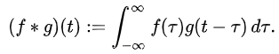
An equivalent definition is:
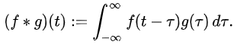
While the symbol t is used above, it need not represent the time domain. But in that context, the convolution formula can be described as a weighted average of the function f(τ) at the moment t where the weighting is given by g(-τ) simply shifted by amount t. As t changes, the weighting function emphasizes different parts of the input function.
For functions f, g supported on only [0, ∞) (i.e., zero for negative arguments), the integration limits can be truncated, resulting in:
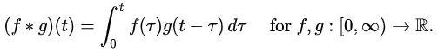
解释: 由信号函数f(t) 和 系统函数 g(t) 得到系统的响应函数
Cross-Correlation
Cross-correlation is a measure of similarity of two series as a function of the displacement of one relative to the other. This is also known as a sliding dot product or sliding inner-product. It is commonly used for searching a long signal for a shorter, known feature. The cross-correlation is similar in nature to the convolution of two functions.
Cross-correlation has other definition in probability and statistics, which is not included here.
Cross-correlation of deterministic signals
For continuous functions f and g, the cross-correlation is defined as:
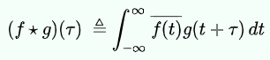
Which is equivalent to
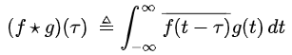
As an example, consider two real valued functions f and g differing only by an unknown shift along the x-axis. One can use the cross-correlation to find how much g must be shifted along the x-axis. One can use the cross-correlation to find how much g must be shifted along the x-axis to make it identical to f. the formula essentially slides the g function along the x-axis, calculating the integral of their product at each position. When the functions match, the value of is maximized.
Autocorrelation
Autocorrelation, also known as serial correlation, is the correlation of a signal with a delayed copy of itself as a function of delay. Informally, it is the similarity between observations as a function of the time lag between them. The analysis of auto correlation is a mathematical tool for finding repeating patterns, such as the presence of a periodic signal obscured by noise, or identifying the missing fundamental frequency in a signal implied by its harmonic frequencies. It is often used in signal processing for analyzing functions or series of values, such as time domain signals.
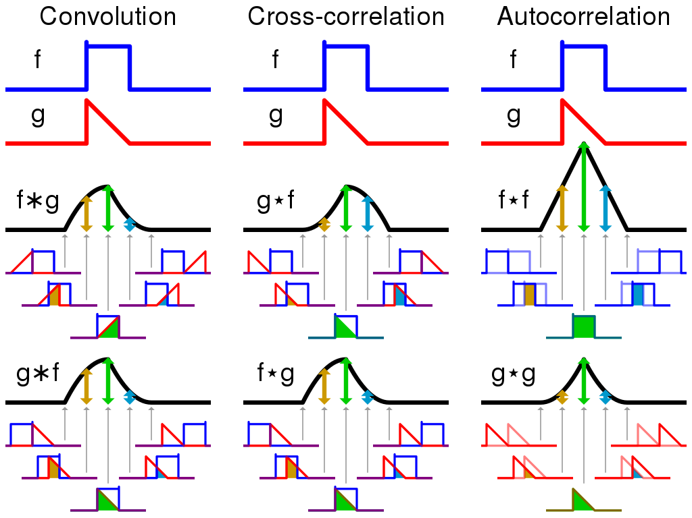
(Wikipedia: convolution & cross-correlation & autocorrelation; zhihu1; zhihu2)
Feb 2021

